HOTEL MANAGEMENT

SYSTEM

MID TERM REPORT

*By*

NAME SECTION ROLL NO

GAUTAM GUPTA K18HV 39

ABHINANDHAN K18HV 43

RISHABH BANSAL K18HV 47

ANISH K18HV 50



Department of Intelligent systems

School of Computer Science Engineering

Lovely Professional University,Jalandhar

April-2019

Student Declaration

This is to declare that this report has been written by us. No part of the report is copied from other sources. All information included from other sources have been duty acknowledged. We aver that if any part of the report is found to be copied ,We are shall take full responsibility for it.

NAME ROLL NO SIGNATURE

GAUTAM GUPTA 39

ABHINANDHAN 43

RISHABH BANSAL 47

ANISH 50

Place :

Date :

TABLE OF CONTENTS

TITLE PAGE NO.

1. Background and objectives of project assigned **4**

1.1 Objective of Project 4

1.2 Role of Each Member 5

1.3 Methodology of Project 6

2. Description of Project **7**

2.1 Sample Code 7-9

2.2 Sample Design 9-11

3. Bonafide Certificate **12**

**Objective of Project**

Main objective of this project is to provide solution for hotel to manage most of there work using computerized process. This software application will help admin to handle customers information, room allocation details , payment details ,billing information etc.

**Role and Responsibilities Of Each Member**

1.**Gautam Gupta**

a. Home page developer

b. Important role in including JavaScript to website

c. Main base website designer using HTML and JavaScript

d. Important role in doing editing of website for making it look good using CSS

2.**Anish Kumar**

a. Data extractor

b. Supporting role in HTML

c. About page developer.

3.**Abhinandan**

a. Founder of how the website should be designed and look alike

b. Concept Designer

c. Landing page developer

4.**Rishabh Bansal**

a. Concept Planner

b. Including HTML

c. Important role in doing editing of website for making it look good using CSS

**Methodology(Detailed Plan)with Timeline Chart(Schedule)**

We were allotted this project on 27 Feb 2k19.Since then we have prepared the very first :

Home page, Booking Page and the assistance interface of our website . We divided the work equally among ourselves , ensuring that each member plays equal role in preparation of this project.

The website also contains 24*7 online support team which would help and guide the user if needed.

To make the interface look more effective and convenient we took ideas from some other sites offering HOTEL MANAGEMENT SYSTEM.

|  |  |
| --- | --- |
|  | ***SAMPLE CODE...***  <!DOCTYPE html> |
|  | <html> |
|  | <head> |
|  | <title>Mardan Palace</title> |
|  | <style> |
|  | body |
|  | { |
|  | background-image: url("Mardan-Palace.jpg"); |
|  | background-repeat: no-repeat; |
|  | background-size:cover; |
|  | } |
|  | .heading |
|  | { |
|  | text-align:center; |
|  | font-size:71px; |
|  | padding:10px; |
|  | font-family: Modern No. 20; |
|  | padding-bottom: 30px; |
|  | height:100px; |
|  | color:gold; |
|  | background: linear-gradient(rgba(00,00,00,1),rgba(00,00,00,0)); |
|  | } |
|  | .ul1 |
|  | { |
|  | list-style-type: none; |
|  | background: rgba(77, 114, 184, 1.0); |
|  | color:white; |
|  | font-size:20px; |
|  | } |
|  | li |
|  | { |
|  | float: left; |
|  | } |
|  | li a |
|  | { |
|  | display: block; |
|  | color:white; |
|  | text-align: center; |
|  | padding: 16px ; |
|  | text-decoration: none; |
|  | } |
|  | li a:hover |
|  | { |
|  | background-color:#ffd700; |
|  | color:; |
|  | } |
|  | </style> |
|  | </head> |
|  | <body> |
|  | <div class="heading">The Mardan Palace |
|  | </div> |
|  | <ul class="ul1"> |
|  | <li><a href="#home">Home</a></li> |
|  | <li><a href="suite.html">Accomodations</a></li> |
|  | <li><a href="contact.html">Contact Us</a></li> |
|  | <li><a href="aboutus.html">About Us</a></li> |
|  | <li><a href="offer.html">Offers</a></li> |
|  | </ul><br><br><br> |
|  |  |
|  | </body> |
|  | </html> |

**Sample Design**

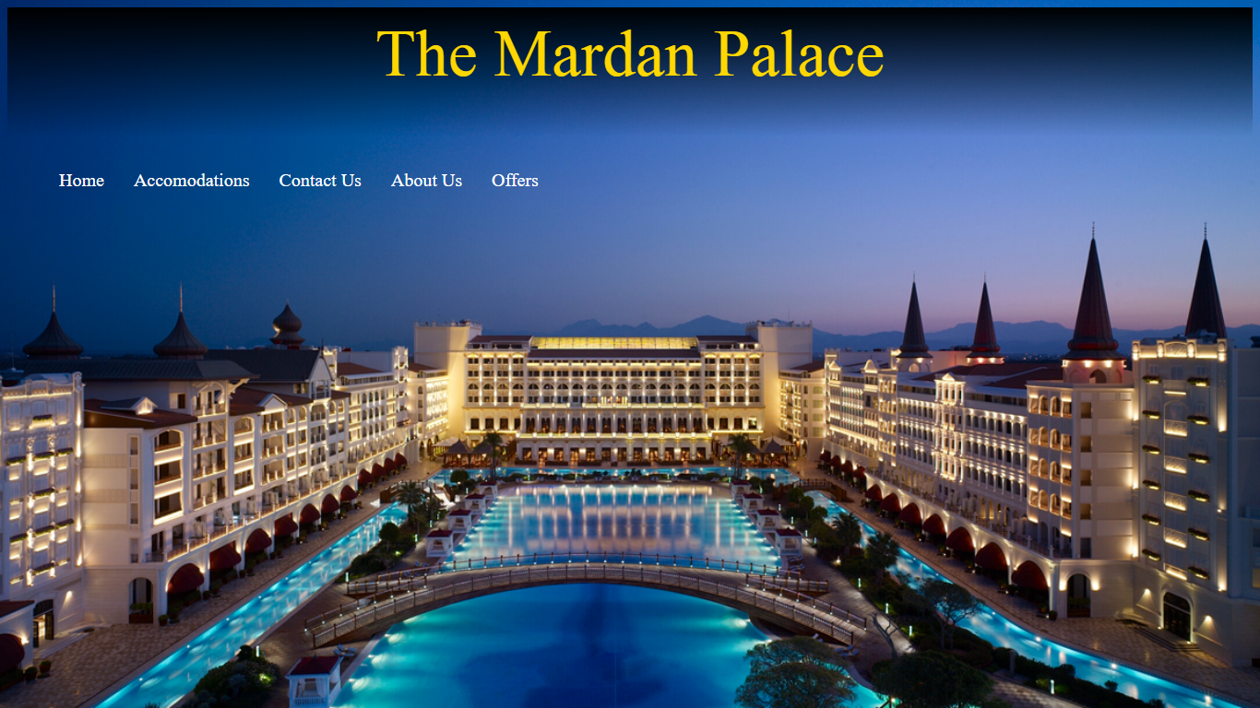

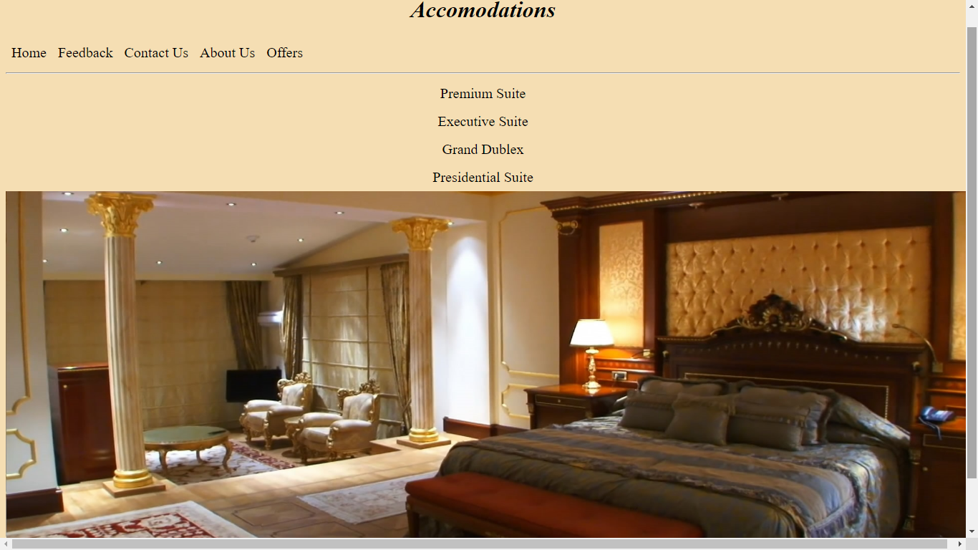

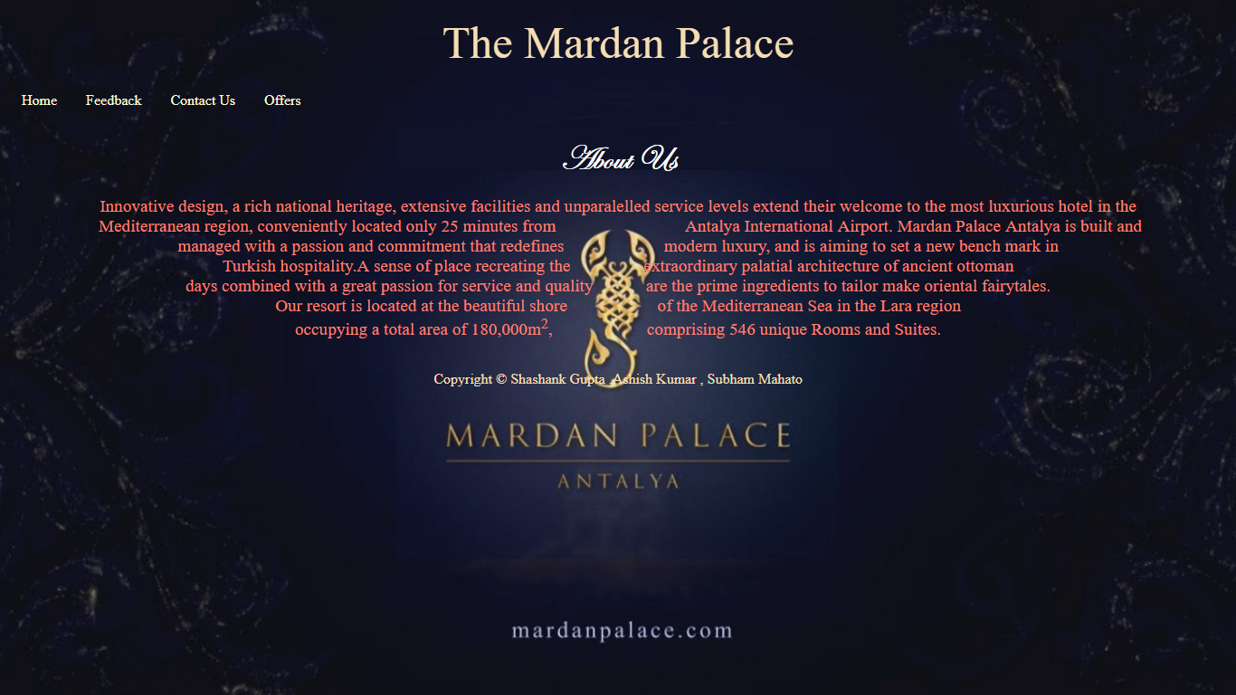

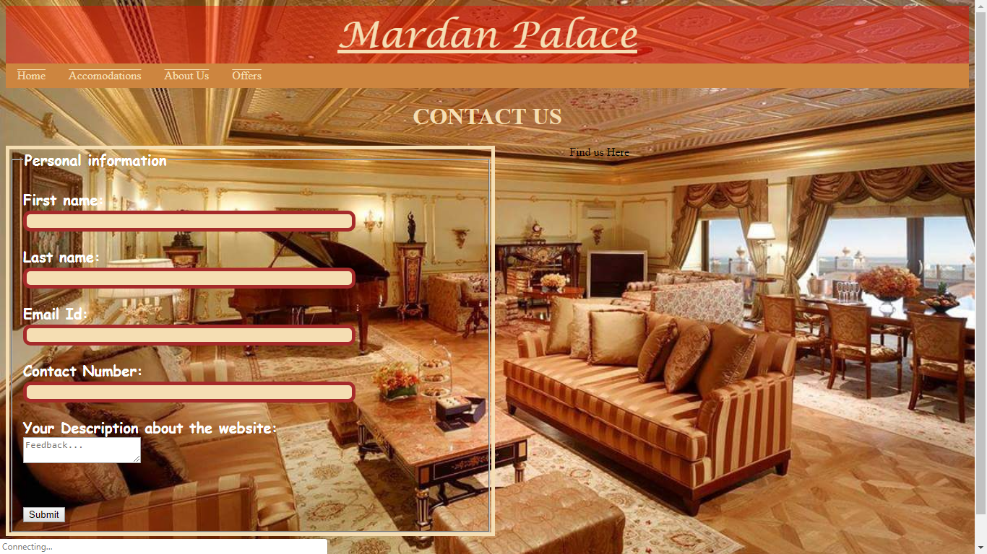

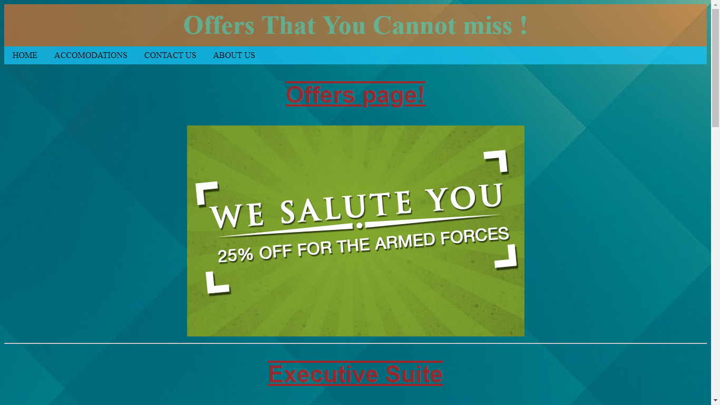

**BONAFIDE CERTIFICATE**

Certified that this project report “ ONLINE SALES MANAGEMENT SYSTEM ” is the Bonafide work of “ Gautam , Abhinandan , Rishabh , Anish ”who carried out the project work under my supervision.

**Signature of Supervisor:**

**Name of Supervisor:**

Dr. V. DEVENDRAN

**Academic Designation:**

Professor

**ID of Supervisor:**

22375

**Department of Supervisor:**

Intelligent Systems